**E-VOTING SYSTEM**

**Project Synopsis**

**<Version 1.0>**

Major Project (MCA 465)

Degree

**MASTER OF COMPUTER APPLICATION**

| PROJECT GUIDE:  **Mr. Vineet Saxena** | SUBMITTED BY:  **Jayant Grover (TCA2163040)**  **Kashish Banga (TCA2163042)**  **Kritika Agarwal (TCA2163045)** |
| --- | --- |

May, 2023



**FACULTY OF ENGINEERING & COMPUTING SCIENCES**

**TEERTHANKER MAHAVEER UNIVERSITY, MORADABAD**

**Table of Contents**

1 Project Title 3

2 Domain 3

3 Problem Statement 3

4 Project Description 3

4.1 Scope of the Work 3

4.2 Project Modules 3

5 Implementation Methodology 3

6 Technologies to be used 4

6.1 Software Platform 4

6.2 Hardware Platform 4

6.3 Tools 4

7 Advantages of this Project 4

8 Future Scope and further enhancement of the Project 4

9 Team Details 4

10 Conclusion 5

11 References 5

# Project Title

E- VOTING SYSTEM

# Domain

A student e-voting system's synopsis domain would probably fall within computer science, particularly in the fields of software development and/or cyber security. The project can entail establishing a user-friendly interface for students to securely and correctly cast their votes as well as designing and deploying a web-based platform for student elections. Creating a backend system to manage the data and guarantee the accuracy of the election results may also be a part of the project. To avoid hacking and other unwanted conduct, the project can also involve putting security precautions like encryption and authentication in place. In general, the summary would concentrate on the technical aspects of developing a strong and trustworthy electronic voting system for use by students.

# Problem Statement

Paper ballots are used in traditional methods of conducting student elections, which are time-consuming, labor-intensive, and prone to errors. Furthermore, such methods lack transparency and are vulnerable to tampering, rendering the election process untrustworthy. Given these obstacles, there is an urgent need to create an electronic voting system that is efficient, secure, and transparent.

A web-based electronic voting system for student elections is what the proposed project seeks to design and create. Students may easily and securely cast their ballots using the system's user-friendly interface. The data will be managed and the accuracy of the election results will be guaranteed by the backend system. To guard against hacking and other sorts of unwanted activities, the system will also have security features including encryption and authentication. The device will also increase openness by enabling authorized individuals to keep an eye on the voting process in real time.

The goal of this project is to develop a dependable, efficient, and secure electronic voting system that will expedite the election process and boost the legitimacy of the results. Students will be able to vote remotely and securely under the proposed approach, boosting voter turnout and guaranteeing that every vote counts. Ultimately, by providing a platform for fair and transparent student elections, this initiative will help to develop digital democracy.

# Project Description

The goal of this project is to create a web-based, secure, effective, and transparent e-voting system for student elections. Students will be able to cast their votes remotely using their choice device and an internet connection from any location. The following attributes will be present in the suggested system:

* User Authentication: Using a unique login and password, the system will authenticate voters, guaranteeing that only approved students can vote.
* Candidate Information: The system will display information on the candidates, including their names
* Voting Interface: The system will offer a user-friendly interface that makes it simple and accurate for students to cast their ballots.
* Real-time Monitoring: The technology will enable authorized staff to monitor the voting process in real-time, assuring accountability and transparency.
* Data Management: The system will securely manage voting data, assuring the accuracy of the election results.
* Security Measures: To avoid hacking and other harmful activity, the system will have security measures such as encryption and authentication.

Increased voter turnout, quicker election results, lower expenses, and greater transparency are just a few advantages of the planned e-voting system. The system will be scalable, making it possible to utilize it in elections for positions at different levels within the organization, such as class representatives, student council members, or faculty representatives. The suggested electronic voting method will, overall, strengthen digital democracy and increase the legitimacy of student elections.

## Scope of the Work

This project's goal is to design and build a web-based e-voting system for student elections. Students will be able to vote remotely from any location using their choice device with an internet connection. The project's scope of work will include the following:

* Collecting and recording the functional and non-functional requirements for the electronic voting system is known as requirement gathering.
* System Design: Creating the user interface, database schema, and system architecture for the electronic voting system.
* System Development: By utilizing current software development approaches, DJango, Python.
* User Authentication: Using a unique username and password for each student to implement user authentication.
* Candidate Information: Information on the candidates, including their names, is displayed.
* Voting Interface: Creating a user-friendly interface that allows students to simply and properly cast their ballots.
* Creating a method for tracking the voting process in real time will ensure accountability and transparency.
* Data management: Creating a safe system to manage voting information and guarantee the validity of the results.
* Security Measures: Putting security measures in place to stop hacking and other malicious acts, such as encryption and authentication.
* Testing and Quality Assurance: Testing and guaranteeing the system's quality and dependability.

The creation of a web-based electronic voting system is the only activity covered under the project's narrow scope, which excludes any hardware installation or configuration. The suggested electronic voting method will, overall, strengthen digital democracy and increase the legitimacy of student elections.

## Project Modules

* User management module: This module will be in charge of managing user accounts, including student registration, login, and password recovery. It will also ensure that the voting mechanism is only accessible to approved pupils.
* Candidate Management Module: This module will be in charge of handling candidate profiles, such as names and other pertinent information. It will also guarantee that the system displays only authorized applicants.
* Voting Module: This module is in charge of overseeing all aspects of voting, including the casting and recording of ballots. It will make sure that students can vote efficiently and properly, and it will also offer real-time voting process monitoring.
* Results management module: The management of the election results, including their calculation and display, shall fall under the purview of the results management module. It will guarantee that the findings are transparent and accurate, and it will also offer real-time results monitoring.
* Security Module: This module will be in charge of assuring the e-voting system's security. To avoid hacking and other malicious acts, it will incorporate security mechanisms such as encryption, authentication, and access control.
* Reports Module: This module will generate reports on the voting process and results. It will enable authorized staff access to and analysis of data, providing transparency and accountability.
* Administration module: The administration module is in charge of controlling the whole system, including user roles, system preferences, and system upkeep. It will guarantee that the electronic voting system is efficient, dependable, and current.

# Implementation Methodology

**CONTEXT DIAGRAM**

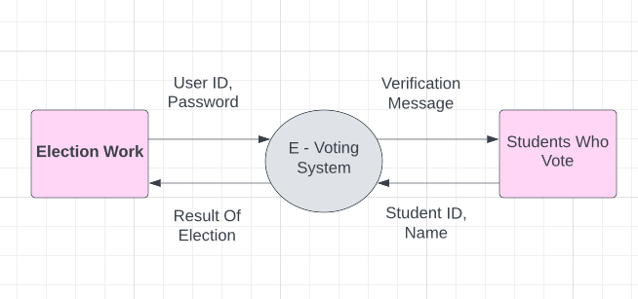

**DFD-1**

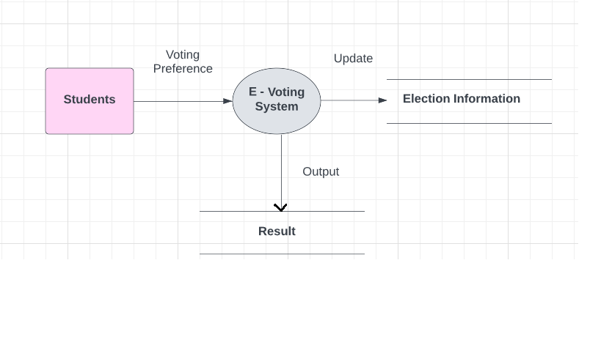

**DFD-2**

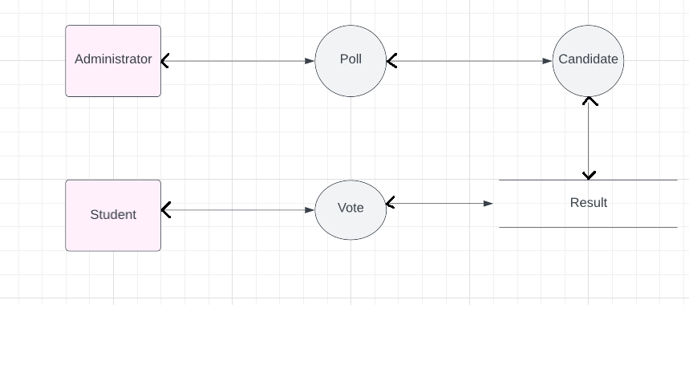

**DFD-3**

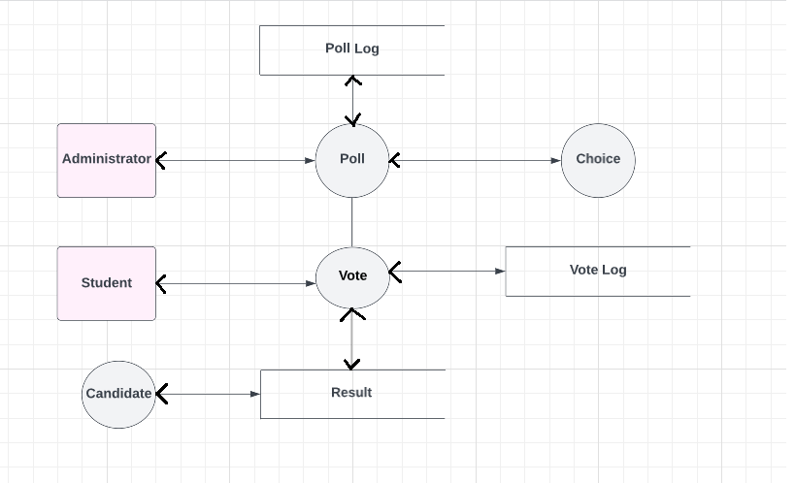

**ERD DIAGRAM**

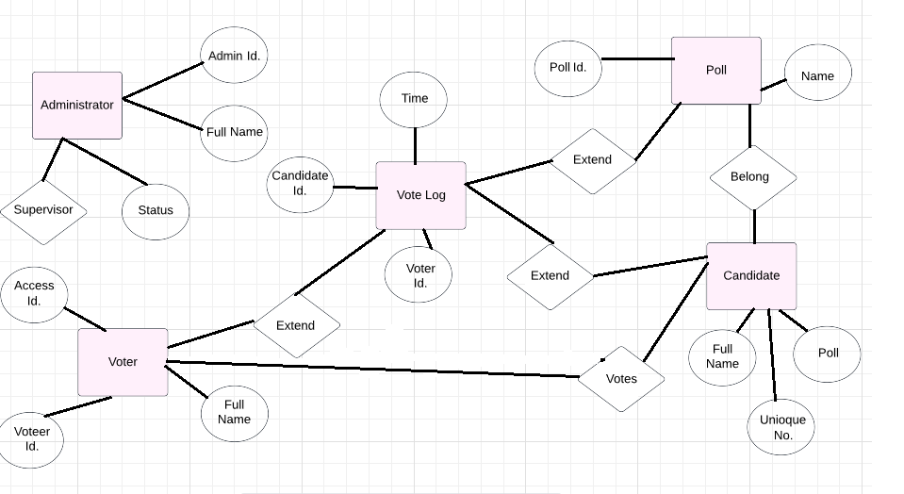

**FLOW CHART**

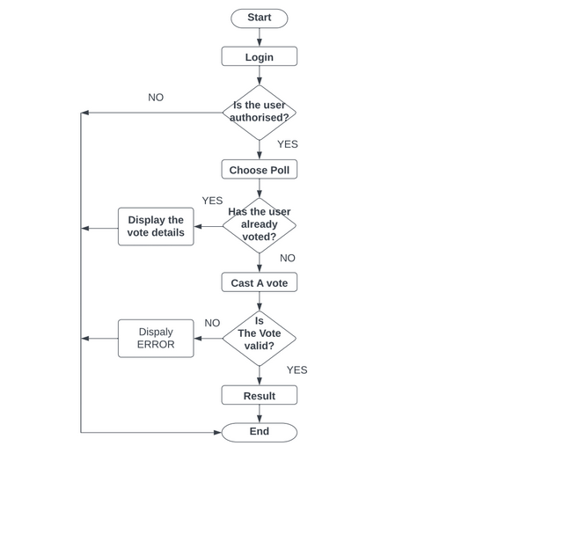

**USE - CASE DIAGRAM**

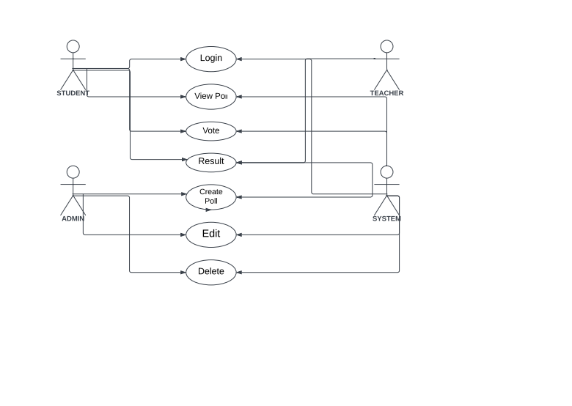

# Technologies to be used

## Software Platform

## 

1. **Front-end**

HTML

CSS

JS

1. **Back-end**

PYTHON

DJANGO

## Hardware Platform

RAM-8GB

Hard Disk-512GB

OS- WINDOWS 10,11

Editor- VS CODE

Browser-CHROME

## Tools

VS CODE

# Advantages of this Project

* Improved Accessibility: The electronic voting method will make voting more accessible and convenient for students. Students may vote from anywhere using any device with an internet connection, saving them time and effort.
* Improved Participation: Because it eliminates the need to physically attend the polling place, the e-voting method will encourage more students to vote in the elections. This will improve student participation in the election process, resulting in a more representative and democratic result.
* Improved Transparency: The e-voting system will monitor the voting process and outcomes in real time, assuring openness and accountability. Students may track the progress of the election and guarantee that their votes are correctly counted.
* Efficiency Gains: Because the e-voting technology automates numerous manual procedures, it will take less time and work to execute the election. Election authorities will have less work to do as a result, and the results will be made accessible more swiftly.
* Improved Security: To stop hacking and other nefarious acts, the electronic voting system will integrate security measures including encryption and authentication. This will secure the privacy of student voters and assure the accuracy of the election results.

# Future Scope and further enhancement of the Project

* Mobile Application: The project's future scope includes the development of a mobile application for the e-voting system. Students will be able to vote using their smartphones and tablets, giving them even greater freedom and convenience.
* Facial recognition: Technology for facial recognition is another improvement to the electronic voting process. By using a picture to prove their identity, students will be able to do away with laborious identification procedures.

# Team Details

| **Project Name & ID** | **Course Name** | **Student ID** | **Student Name** | **Role** | **Signature** |
| --- | --- | --- | --- | --- | --- |
|  |  |  |  | Developer, Testing etc. |  |
|  |  |  |  |
|  |  |  |  |
|  |  |  |  |
|  |  |  |  |

# Conclusion

Finally, the E-Voting System for Student Elections represents a substantial improvement in the election process, offering various advantages over traditional paper-based voting methods. The technology will improve student elections' accessibility, participation, openness, efficiency, and security.

Among the project components of the e-voting system are voter registration, candidate nomination, and vote casting. The technology may be improved further using mobile applications and facial recognition.

The use of an electronic voting system will guarantee that student elections are handled in a democratic, open, and reliable manner. More students will take part in the election as a result, resulting in a more representative conclusion. The approach will also conserve time, money, and resources, making student elections more affordable and effective.

The E-Voting System for Student Elections, in its entirety, makes a substantial contribution to the education sector by encouraging student engagement, democratic principles, and technological improvements.

# References

https://ijcrt.org/papers/IJCRT2108461.pdf

https://www.csjournals.com/IJEE/TUMKUR/18.%20Darshan.pdf

https://jpinfotech.org/online-election-system-online-voting-system/

https://www.electionsonline.com/online-voting-system/

https://www.w3schools.com/

https://en.wikipedia.org/wiki/Electronic_voting